
STUDENT Behind-the-Wheel DRIVER ED ONLINE
REGISTRATION PROCESS
(must have a learner’s permit and 10-12 hours of driving completed prior to registration)
- Please visit our Patriot Behind the Wheel Website for information: www.tinyurl.com/PatriotBTW
(print the three forms in the registration folder in the file section. Submit the 3 forms with online credit card payment receipt. Registration is not complete without the permission forms and student info)
- To register for the course log into: www.tinyurl.com/PWCSDriverEd
- Click on Register Now …. below Range and Road (Academic Year) / $240 (online credit card payment receipt)
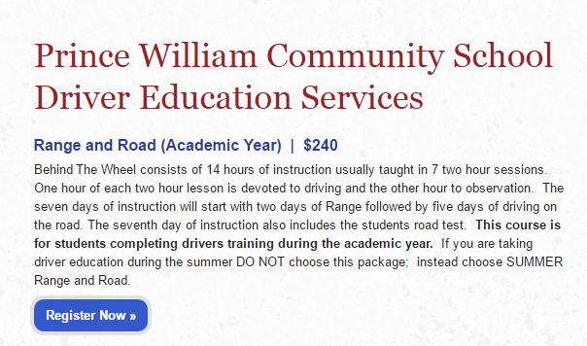
- Complete Student Information section
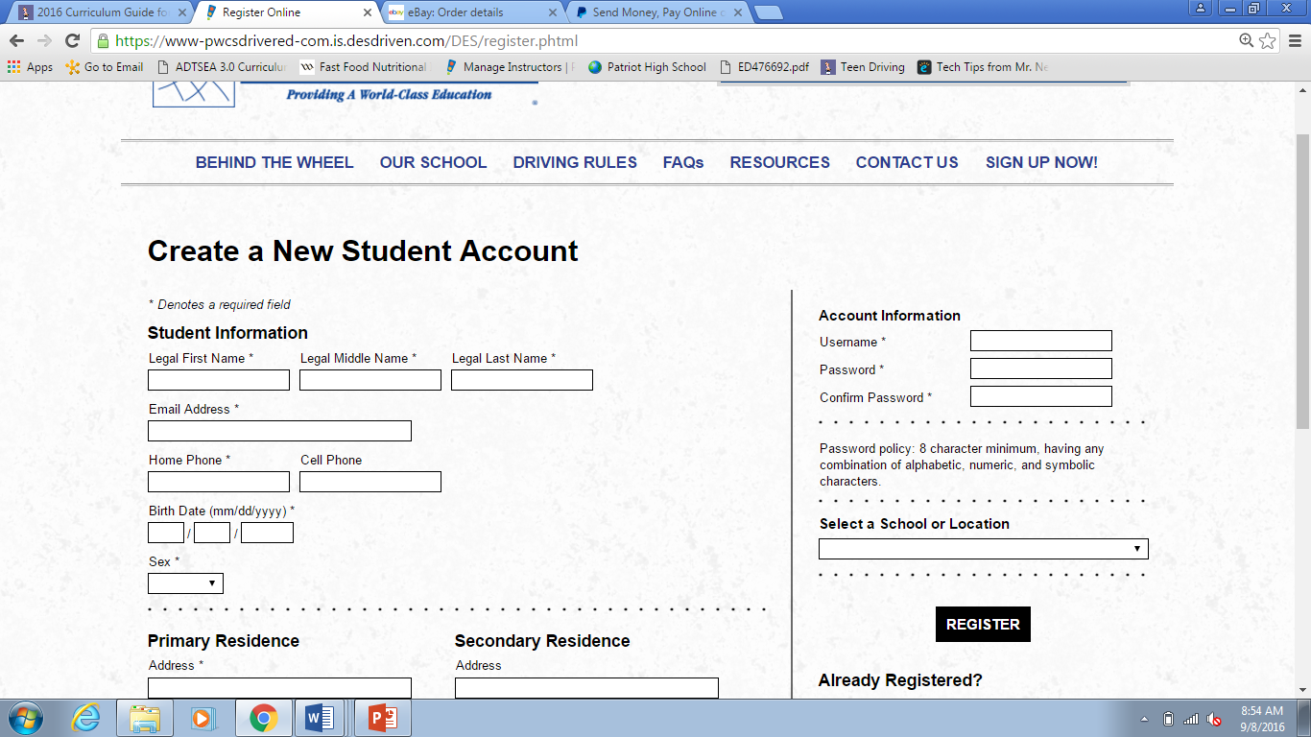
- Scroll down to Parent Information: Fill out information for one or both parents
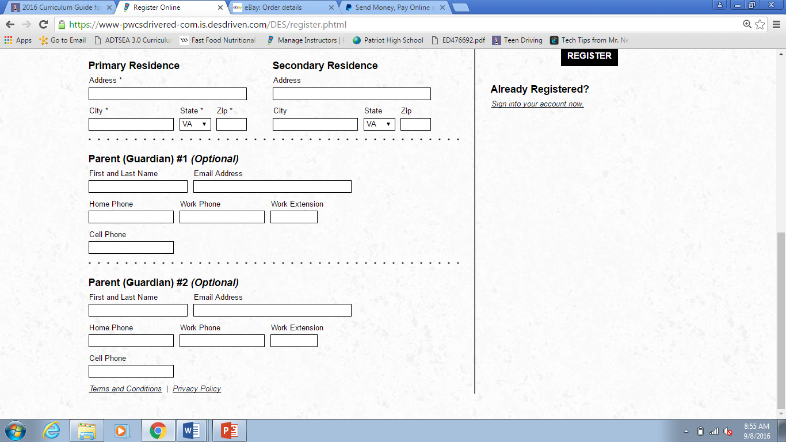
- At top right of page create Username and Password
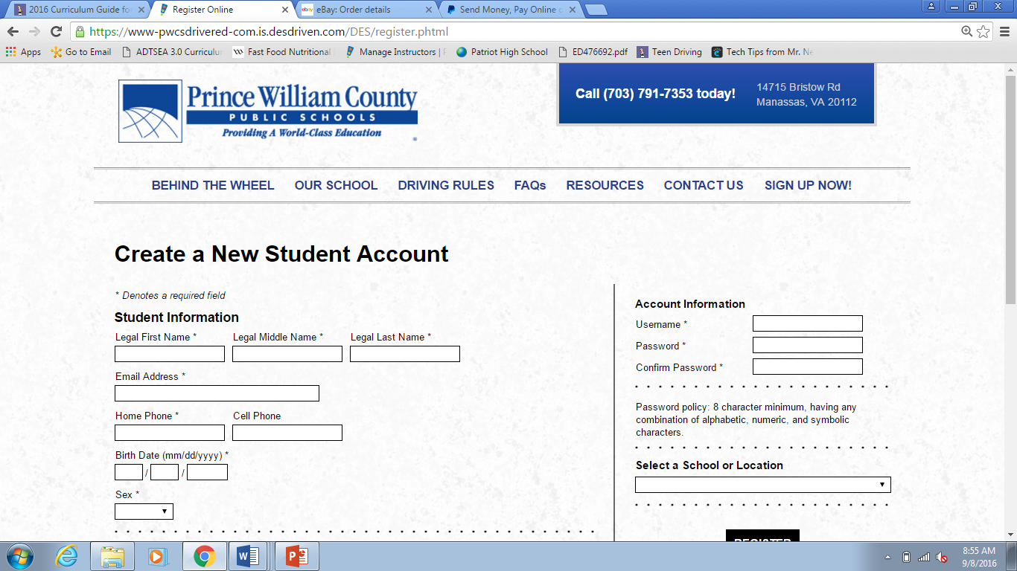
- Select Your School
- Click on Register. The screen will change to show Courses and Terms of Service. After reading the terms, click “Agree to Terms” box. Click Submit.
- This will take you to Your Account Ledger. It will show an outstanding balance of $240.
- Before you will be able to schedule your sessions for BTW (Behind-the- Wheel) you must make payment.
  - Credit card payments accepted: Visa, Visa Debit, Mastercard, and Mastercard Debit.
    - You may pay the Driver Ed fee through the secure online website that is accessed through the following website: https://www.studentquickpay.com/pwcs
    - Parents will create an account by clicking the yellow Sign In icon.
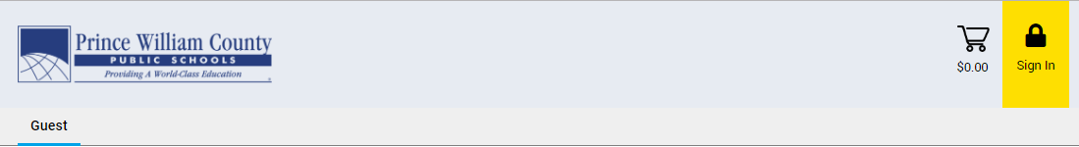
    - When the Sign In window pops up, click on the Create Account button.
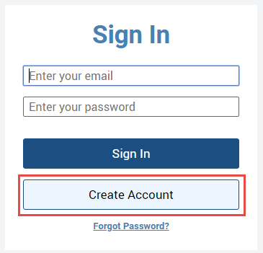
    - Sign-up with your First Name, Last Name and E-mail.
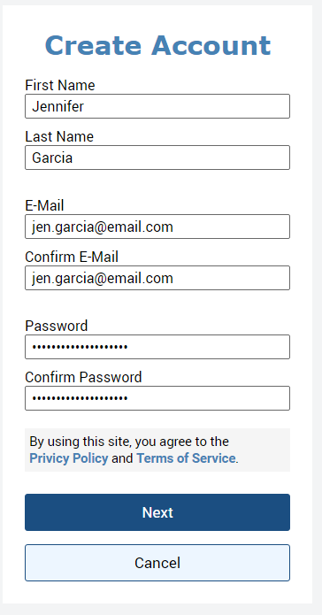
    - Choose a Password and Confirm your Password.
    - Click on the Next button.
    - Click on the Add student button.
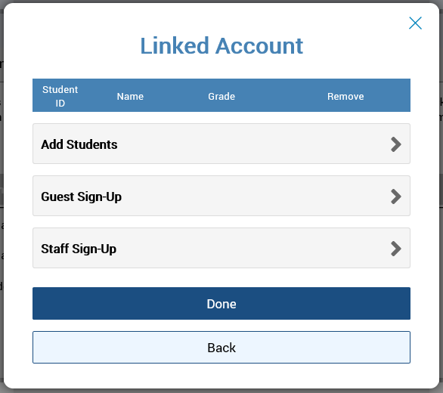
    - To add students to your parent account, will need your children’s Student ID number and Last Name.
    - Click on the Add Student Button
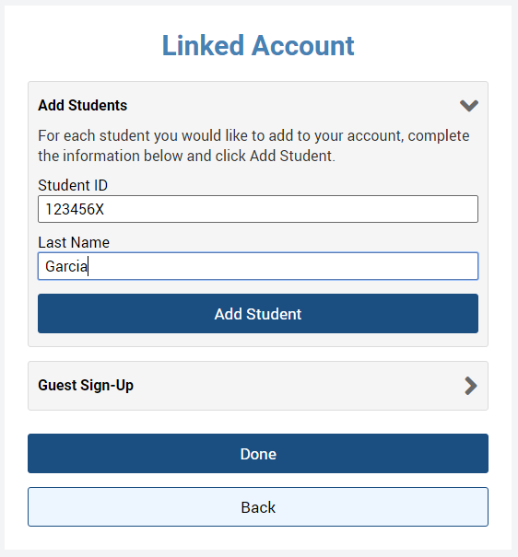

    - The student should appear under the Linked Account window if they have successfully been added to your account.
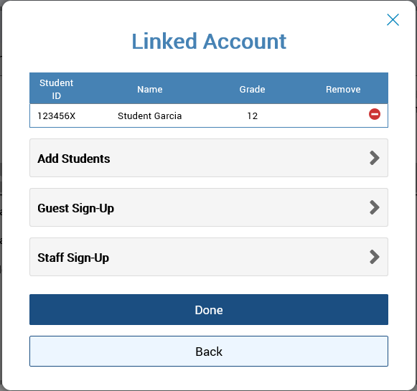

    - If you have more children to add to your account, click on the Add Students button again and repeat the above steps.
    - If you only have one student attached to your parent account, you will immediately be brought to their individual student account, where you can view their fees and add optional items to your cart. When ready, you can click on the shopping cart icon in the top right-hand corner to check-out and make an online payment.
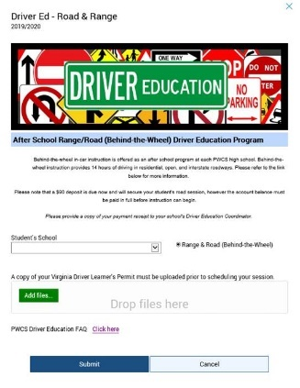
    - When you are done reviewing your student(s) account balance, please click on the shopping cart icon in the top right-hand corner to check-out. Parents can make a single payment online that covers multiple children and unlimited fees and optional items at different schools across the district.
    - Please print out the receipt that will be emailed to you and submit with the forms to Mrs. Dignan.
- Complete the forms, located in the Behind-the-Wheel Registration File Folder in the section at the bottom of this site. (Driver Ed Student Information, Parent Permission #1 and Parent Permission #2).
  - Email Mrs. Dignan (dignanam@pwcs.edu): Email credit card receipt, all forms (Driver Ed Student Information, Parent Permission #1 and Parent Permission #2) and a copy of your DEC-District 8 Certificate of Completion (pink card).
  - IMPORTANT: Please DO NOT submit any paperwork to the main office! All paperwork must be submitted via EMAIL to dignanam@pwcs.edu.
- Mrs. Dignan will mark you paid after receiving all items/ registration forms (mentioned above) via email ONLY. Important: When your balance reads $0 you will be able to schedule your range and road sessions. Please allow 2-3 business days for the coordinator to complete this process.
SCHEDULING YOUR SESSIONS
- After submitting required forms and payment receipt please log back into your account (www.tinyurl.com/pwcsdrivered). If your account balance is $0, you may schedule your sessions. When scheduling your session, you should select TWO consecutive RANGE dates and FIVE consecutive ROAD dates. Please note: you MUST complete 2 sessions of range instructor BEFORE your road sessions begin. Please schedule with the same instructor for all sessions. ** We require 2 students to be enrolled in a session for it to begin. **
- Your schedule will automatically be added to your student account that you created during registration. Please check frequently for updates to the schedule by logging into your account.
- You will need to confirm your email and/ or text in order to receive alerts and notifications. Under the personal information section of your account, please check how you would like notifications to be sent to you.
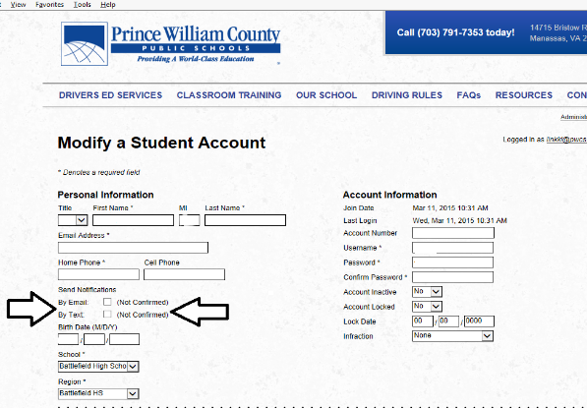

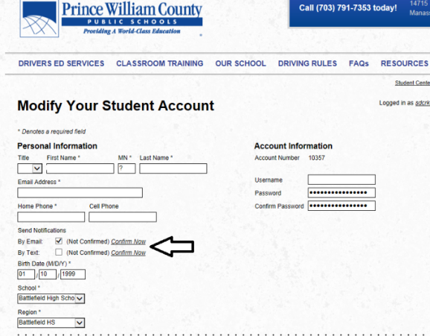
- Please click Confirm Now

- You will receive an email and/or text with a four-digit code. Please put that 4 digit code into the box. You will not receive any alerts indicating your schedule or changes made to the schedule if you do not complete steps 3-4. You will be reminded of a scheduled session by email and/or text. If you are unable to make a schedule session, proper notice must be given to the coordinator by logging into your account and leaving an email message or you must see the instructor in person to cancel. Missed sessions without notification will result in a $25 cancellation fee.
