AP English Language and Composition Summer Reading Assignment

Due Date: Tuesday, September 1
For this assignment, create an analytical nonfiction text file folder using the text list below. As you read, take note of the book’s rhetorical choices, or ways in which the author presents or enhances a story or argument; its structure; lines of reasoning; and rhetorical situation. After reading, you will demonstrate your learning through a file folder project through the components listed below. This project is designed to introduce you to rhetorical analysis and close reading skills central to AP English Language and Composition. Successful projects will move beyond summary to analyze how authors use language, structure, and rhetorical choices to shape meaning and influence readers.

Your folder should be organized, legible, and thoughtfully assembled. Creativity and visual presentation matter, but strong analytical thinking and textual engagement are most important. While you may discuss your book with others, your written work should be original and independently composed. All written responses should reflect your own thinking and analysis. AI is not permitted for this assignment.

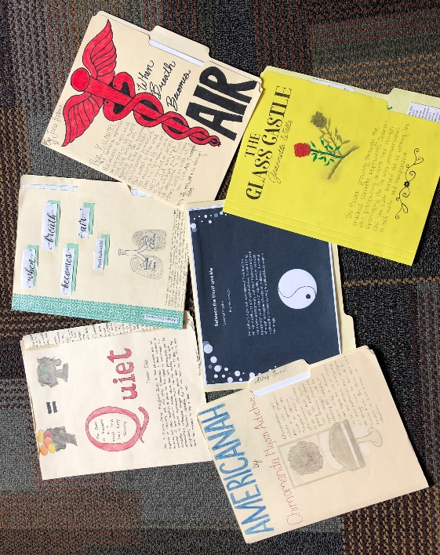
Student Samples
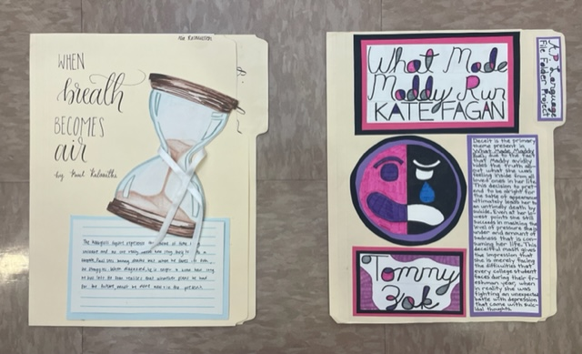
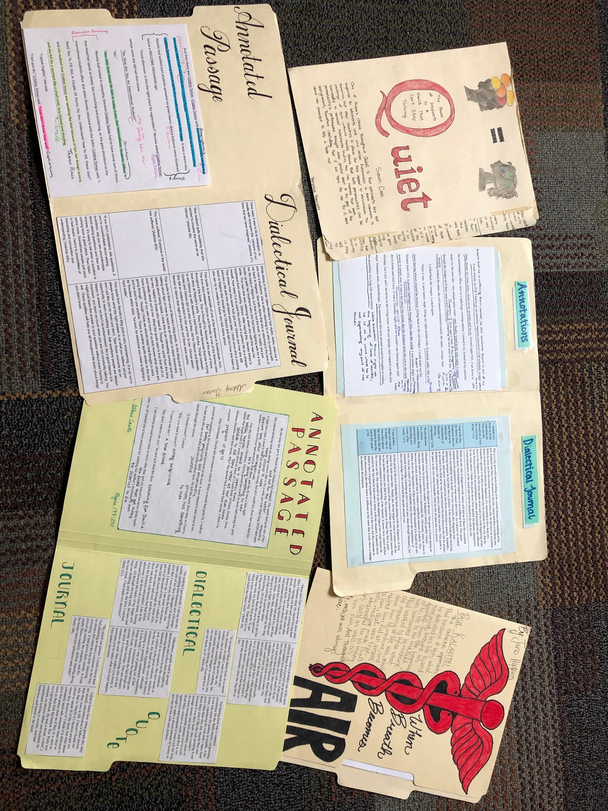

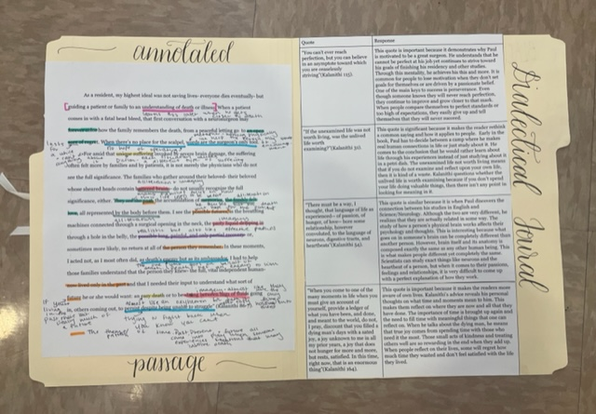

Folder Directions:
FRONT of folder  (Symbol)  - Write the title & author on the front  - Draw an image that you think represents one of the major ideas/themes/people in the book you read. Near the symbol, write the theme, idea, or person’s name and a well-crafted 5 – 7 sentence explanation of how the symbol is representative of this element of the text. Avoid choosing symbols that are overly obvious or generic. Strong symbols reveal something meaningful, complex, or nuanced about the text and should connect clearly to the author’s larger message or purpose.  - Write your name somewhere on this side. | BACK of folder  (WE CAMP analysis)  On the back of your folder, write the acronym WE CAMP down the side. Your responses should focus on analysis rather than plot summary. In strong rhetorical analysis, you explain not only what the author does, but why those choices matter and how they shape the reader’s understanding of the text.  For each letter, you must write a concise, thoughtful paragraph (approximately 3–5 sentences) for each component detailing:  W - important/relevant information about the writer  E – exigence: the moment, event, situation, or issue that prompted the author to write the book  C - year of publication and relevant historical/cultural context; the setting of a non-fiction text  A - the author’s intended audience and their needs/beliefs/values; the author’s relationship to this audience  M- the message of the text; this would include a summary to communicate the content  P - a purpose statement describing what the author wants the book to achieve or accomplish
INSIDE LEFT of folder  (Annotated Passage)  Type or copy, annotate, and cite one passage from the book that you found particularly moving or important, and which exemplifies the author’s writing style. The passage should be approximately two-thirds (2/3) to a full page when double-spaced.  This passage should be in the middle/end of the text, near the tonal shift  Annotate by highlighting, circling, boxing, and/or underlining important aspects of the text, then adding notes in the margins about the words you marked.  Think about how the author achieves their purpose through this piece of writing. Look for powerful diction, appeals, syntax (sentence structure), figurative language, allusions, etc. Strong annotations go beyond labeling devices; they explain how the author’s choices contribute to tone, purpose, meaning, or impact on the audience. | INSIDE RIGHT of folder  (Mini Dialectical Journal)  Divide the inside right folder into two columns. Choose 4 meaningful short passages from your book. Each quote should come from a different quarter of the book (approximately). Write these passages in the LEFT column. In the RIGHT Column, write a 100 word (minimum) response to each quote. Why is this an important quote? How does it contribute to the meaning of the text? Effective responses should analyze the quote’s significance rather than simply summarize the surrounding events in the text.
  Quote (page #) | Response… (at least 100 words)

List of Texts

Choose a text from the list below to complete your project. You are welcome to listen to an audio book; however, you will need to refer to a printed copy for the close reading activities required for this assignment. Please note: some of these books may contain content that is sensitive to readers. Make sure you have a conversation with your parents or legal guardian about your book selection!

Note: Most texts exist in more than one category

If there is a text that you want to read that is not on this list, please email Mrs. Ortiz for approval. You can reach her at ortizem@pwcs.edu. Please note that she will veto any text covered in 9th and 10th grade.

Autobiography/Memoir
- I Know Why the Caged Bird Sings - Maya Angelou
- Educated - Tara Westover
- Crying in H-Mart - Michelle Zauner
- Hunger: A Memoir of (My) Body - Roxane Gay
- A Long Way Gone: Memoirs of a Boy Soldier - Ishmael Beah
- Farewell to Manzanar - Jeanne Wakatsuki Houston and James D. Houston
- Dreams from My Father: A Story of Race and Inheritance - Barack Obama
- Fresh Off the Boat: A Memoir - Eddie Huang
- Bento Box in the Heartland - Linda Furiya
- Somebody's Daughter: A Memoir - Ashley C. Ford
- Black Dove: Mama, Mi’jo, and Me - Ana Castillo
- Barbarian Days: A Surfing Life - William Finnegan
- Beautiful Country - Qian Julie Wang

Class and Money
- Nickel and Dimed: On (Not) Getting By In America - Barbara Ehrenreich
- Somebody's Daughter: A Memoir - Ashley C. Ford

Race
- I Know Why the Caged Bird Sings - Maya Angelou
- The Heritage: Black Athletes, a Divided America, and the Politics of Patriotism - Howard Bryant
- Bento Box in the Heartland - Linda Furiya
- Black Dove: Mama, Mi’jo, and Me - Ana Castillo
- Between the World and Me - Ta-Nehisi Coates

History
- The Power of Babel - John McWhorter
- Farewell to Manzanar - Jeanne Wakatsuki Houston and James D. Houston
- A Long Way Gone: Memoirs of a Boy Soldier - Ishmael Beah
- Reading Lolita in Tehran - Azar Nafisi
- Stamped from the Beginning: The Definitive History of Racist Ideas in America - Ibram X. Kendi
- All That She Carried: The Journey of Ashley’s Sack, a Black Family Keepsake - Tiya Miles

Food and Nutrition
- Fast Food Nation: The Dark Side of the All-American Meal - Eric Schlosser
- Animal, Vegetable, Mineral: A Year of Food Life - Barbara Kingsolver
- Hunger: A Memoir of (My) Body - Roxane Gay

Science
- Braiding Sweetgrass: Indigenous Wisdom, Scientific Knowledge and the Teachings of Plants - Robin Wall Kimmerer
- Stiff: The Curious Lives of Human Cadavers - Mary Roach
- Everything Is Tuberculosis - John Green
- How Far the Light Reaches - Sabrina Imbler
- Astrophysics for People in a Hurry - Neil deGrasse Tyson

Essays
- The Awkward Thoughts of W. Kamau Bell: Tales of a 6' 4", African American, Heterosexual, Cisgender, Left-Leaning, Asthmatic, Black and Proud Blerd, Mama's Boy, Dad, and Stand-Up Comedian - W. Kamau Bell
- How Far the Light Reaches - Sabrina Imbler
- Stamped from the Beginning: The Definitive History of Racist Ideas in America - Ibram X. Kendi
- The Undocumented Americans - Karla Cornejo Villavicencio
- Between the World and Me - Ta-Nehisi Coates

Comedy
- The Awkward Thoughts of W. Kamau Bell: Tales of a 6' 4", African American, Heterosexual, Cisgender, Left-Leaning, Asthmatic, Black and Proud Blerd, Mama's Boy, Dad, and Stand-Up Comedian - W. Kamau Bell
- Why Is Everyone Hanging Out Without Me- Mindy Kaling
- Fresh Off the Boat: A Memoir - Eddie Huang

Sports
- The Heritage: Black Athletes, a Divided America, and the Politics of Patriotism - Howard Bryant
- Moneyball - Michael Lewis

Crime
- Know My Name - Chanel Miller

