

Name:

Teacher:

Class Period:

School & Year:

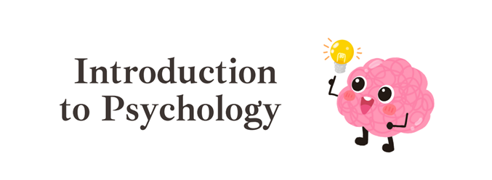

Unit Zero Standards:
- Apply psychological perspectives, theories, concepts, and research findings to a scenario.
- Explain how cultural norms, expectations, and circumstances, as well as cognitive biases apply to behavior and mental processes.
- Determine the type of research design(s) used in a given study.
- Evaluate the appropriate use of research design elements in experimental methodology.
- Evaluate the appropriate use of research design elements in non-experimental methodologies.
- Evaluate whether a psychological research scenario followed appropriate ethical procedures.
- Identify psychology-related concepts in descriptions or representations of data.
- Calculate and interpret measures of central tendency, variation, and percentile rank in a given data set.
- Interpret quantitative or qualitative inferential data from a given table, graph, chart, figure, or diagram.
- Propose a defensible claim.
- Provide reasoning that is grounded in scientifically derived evidence to support, refute, or modify an established or provided claim, policy, or norm.

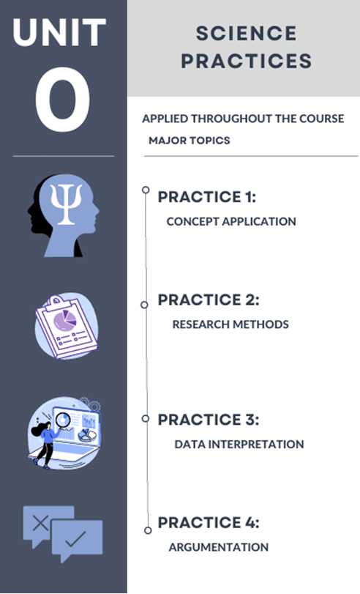

Research Methods in Psychology
- Explain the three key elements of the scientific attitude?
A. Curiosity:

B. Skepticism:

C. Humility:

- Define critical thinking.

- How does critical thinking challenge common sense?
Critical inquiry can surprise us and can debunk popular presumptions.
Here are some examples:
- Massive losses of brain tissue early in life may have minimal long-term effects
- People of differing age, gender and wealth report roughly comparable levels of personal happiness.
- Depression touches many peopled but most recover

- Define and provide examples of each.
  - Hindsight bias:

  - Overconfidence:

  - Perceiving Order in Random Events:

- Describe how theories advance psychological science.
We often use “theory” to mean a mere hunch, but in science, a theory explains behaviors or events by offering ideas that organize observations. By using deeper principles to organize isolated facts, a theory summarizes and simplifies. As we connect the observed dots, a coherent picture emerges.
Example: a theory of how sleep affects memory helps us organize countless sleep-related observations into a short list of principles. So, if we observe over and over that people with good sleep habits tend to answer questions correctly in class and do well at test time, then we might therefore theorize that sleep improves memory. Thus, our principle neatly summarizes a list of observations about the effects of a good night’s sleep.

- Define and/or provide examples of each of the following terms.
  - Peer reviewers:

  - Theory:

  - Hypothesis:

    - Null Hypothesis:

  - Falsifiable:

  - Operational definitions:

  - Replication:

- What “role” does a survey play in research methods?

  - In what types of research methods willy ou see a survey being used?

  - Give examples of a survey.

  - Explain the importance of wording effects:

- Explain the following challenges to research.
  - Social-desirability bias:

  - Self-report bias:

  - Sampling bias:

- How do you find participants?
  - Population:

  - Sample:

  - Random sample/selection: What do mean by random (<--synonym?)

    - What is a representative sample? Provide an example.

- What do we mean by GENERALIZATION?

  - Why do we need a good random sample to generalize our results to the population?

  - Provide an example of when results can be generalized to a population?

- Non-experimental Methods
Method | Purpose | Examples
Case Study

Naturalistic Observation

Correlational Studies

Meta-Analysis

True or False: Any of the above types of research can be generalizable with a good random sample? Can you explain why or why not?

- What is correlation and how is it used in psychological research?

- Elements of Correlational Research
  - Correlational coefficients (scale of _____ to _____, with _____ being no correlation)

  - Variables:

  - Scatterplot:

- Draw the scatterplots and provide examples of each type of correlation.
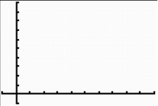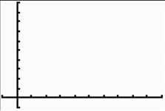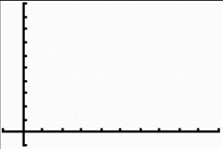
Perfect Positive (+1) No Correlation (0) Perfect Negative (-1)
Ex. Ex. Ex.

- Does correlation indicate causation? Explain your answer. Provide an example.

- Identify the problems with correlation.
  - The Third Variable Problem (sometimes referred to as an Illusory correlation):

  - Regression towards the mean:

- Why are experimental methods used?

- Elements of an Experiment
  - Independent variable:

  - Dependent variable:

  - Experimental group:

  - Control group:

  - Random assignment:
    - What do mean by random (<--synonym?)

    - How is random assignment done?

    - What type of “bias” does random assignment reduce?

    - What does random assignment allow when done correctly?

    - What is difference between random sample and random assignment?

True or false: Can the results of an experiment be generalizable? Can you explain why or why not?

What do you need for results to be generalizable?

What do you need for results to show cause and effect?

- More potential confounding variables and ways to control:
  - Hawthorne Effect

  - Single blind study:

  - Double blind study:

  - Placebo:

- Challenges to Experimental Methods:
  - Placebo effect:

  - Confounding variables:

  - Experimental bias: (What can you use to reduce experimenter bias?

    - Review: what can you use to reduce participant bias?

  - Validity:

What helps to create “external validity” and why?

What helps to create “internal validity” and why?

  - Reliability:

- REVIEW: Comparing Methods (Non-Experimental versus Experimental)
Method | Purpose | How Conducted? | Manipulation? | Weakness
Non-  Experimental | 1. Case Study  2. Naturalistic Observation  3. Correlational Study  4. Meta-Analysis
Experimental

REMEMBER: The survey is NOT a Research Method. Instead it is just “tool” we can use to collect data. For example, you can use a survey to collect data for a correlation study on whether sleep impacts student’s grades. Or you can use a survey to collect data for an experiment as a measure of your dependent variable (have people complete a Likert Scale on their emotional happiness after you expose them to horror movies).

- Explain the difference between quantitative and qualitative research.
 | Type of data collected | Example | A Mnemonic to remember
Quantitative

Qualitatitve

- What are the ethical guidelines of psychological research?
    - Voluntary Participation/Informed Consent and Informed Assent (and explain the difference):

    - Anonymity/Confidentiality:

    - Protection from Harm:

    - Wat deception used with a confederate?

    - Must debrief:

- Why is it important to ensure scientific integrity?
In science, as in everyday life, mistakes happen. When data get accidentally miscomputed or misreported, that’s forgivable and correctable. What's not acceptable- and will get a scientist banished from the profession—is fraud! Leading scientists cite honesty as the most important scientific value, followed by curiosity and perseverance. Moreover “fake science” has the potential to cause great harm. (See textbook at page 0-36).

- How do psychologists’ values influence their research and the application of their findings?
Psychologists’ values influence their choice of research topics, their theories and observations, their labels for behavior, and their professional advice.
Applications of psychology’s principles have been used mainly in the service of humanity.

- Why do we need statistics?

  - What is the problem with statistical illiteracy?

  - And what are the two main types of statistics?
- What are descriptive statistics?

  - What CAN you do with descriptive statistics?

  - What can you NOT do with descriptive statistics?

- Descriptive Stats: How do we describe data? Define and provide an example:
  - Correlations

  - Histograms & Bar Graphs

  - Measures of Central Tendency (Mean, Median, Mode ~ How close or similar the numbers are to each other)
    - Mean:

    - Median:

    - Mode:

    - Bi-modal Distributions

  - Percentile rank:

  - Measures of Variability (Range & Standard Deviation ~How far apart the numbers are from each other):
    - Range:
    - Standard deviation: (And draw a three normal bell curves with a small, medium and large deviation).

- Draw and explain the difference between normal distribution and skewed distribution (negative & positive).
  - Required for the AP Psychology Exam: Explain the elements of the normal curve including percentages of distributions of scores across the curve, how to interpret skewness in a graph, and how to interpret a bimodal distribution.

Draw the percentages of distributions of scores across this curve:

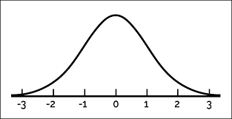 | Remember the mnemonic:  A 68-year-old man was driving along I-95 going 99 miles per hour.  “68-95-99"

Explain what is happening in these skews (and are they normal, positive or negative?).

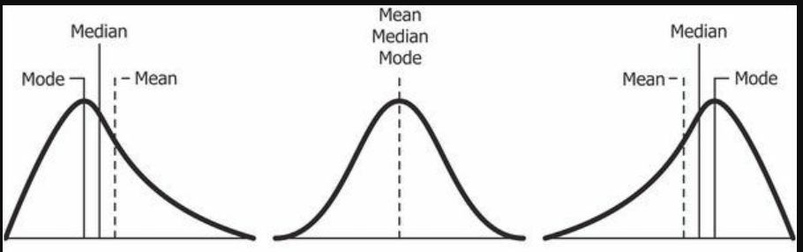

Explain what is happening in this bimodal distribution:

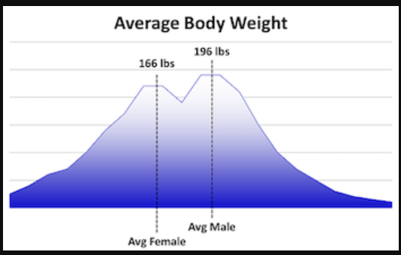

- What are inferential statistics?

- What must be included in research to make it generalizable (applicable to the population)?

- What does it mean for results to be statistically significant?

- What is effect size?

Miscellaneous Unit 0 Information

