**Filling Out the College Application: FAQ’s**

***Who is my School Counselor?***

|  |  |
| --- | --- |
| **Counselor** | **Last Names** |
| Ms. Kerns | A-Car |
| Ms. Portell | Cas-Fe |
| Ms. Campbell | Fi-Jon |
| Ms. Lutkenhouse | Joo-Me |
| Ms. Valentino | Mi-Q |
| Mr. Banks | R-St |
| TBA | Su-Z |
| Ms. Boddie | College and Career Counselor |
| Ms. Snoots | Counseling Director |
| Ms. Baltimore | Transcript Secretary |

**Check the PTHS School Counseling home page for your counselor’s full name and email address.**

***How do I log into Naviance?***

* Go to ***https://student.naviance.com/patriot***
* Click “Log in with Clever”
* Go to your Office 365 account and log in to Naviance

***How do I request letters of recommendation?***

*If your* college **requires** a letter(s) of recommendation, first ask your teacher(s) (in person or by email) if you may list them as a recommender. Then, you must request in Naviance, allowing at least 15 school days to write a letter. November 15th should be the latest date to make your request. **Provide your teachers additional information via a resume and senior questionnaire for a strong letter**. See **Naviance Tip Sheet** for instructions.

***How do I request transcripts and send to colleges?***

Most colleges require that you request **PTHS** to send your transcripts. Please request your transcript in Naviance. **After that point, Ms. Baltimore will automatically send your initial, mid-year, school profile, and CA/Secondary School Report for that school.** We will send one final transcript to only the one school that you choose to attend which will be recorded on your end of year senior survey.

If the college DOES NOT take transcripts, you MUST complete the college’s ***Student Reported Academic Record* (SRAR)** application online on the college’s website. An example of this is Penn State! Be sure to check each college’s requirements. **It’s the student’s responsibility to report his/her records.**

**Self-reported** school means that you must type your transcript as it is printed into your common application, coalition application or SRAR database. “Advanced courses” are indicated by a weighted credit. See your transcript.

PWCS only sends documents via Naviance Student (eDocs) and the mail. We are not able to create separate coalition accounts. Do NOT send any requests for documents through your college application. Naviance Student will connect to your Common Application account and all other types of applications-documents will be sent electronically to the institution if not noted as mailed.

***How do I pay for my transcripts?***

Your first 3 transcripts are free. To pay for additional transcripts, you may use the PWCS electronic Student QuickPay system. Transcripts used for scholarship applications and NCAA are also free.

***HOW does PWCS report GPA?***

**PWCS calculates GPA in June at end of year and again at end of 1st semester in January. Your current transcript shows your GPA at the end of Junior year.**

**On the transcript your GPA is**

* Weighted
* Based on a 4.0 Scale
* Ranked

***How do I send my test scores to colleges?***

You must request your **SAT scores** **directly from College Board and ACT scores from ACT.org.** Log into your College Board account(s) and go to *Send Score Reports*. Scores on your PWCS transcript are NOT official. There is a cost after you’ve already tested. You are given four free reports at the time of registration.

***What does TEST OPTIONAL mean?***

Students have the option of submitting test scores or not. Those not submitting will not be penalized. Colleges will consider the scores of those who submit. So, if your score is in line or higher than what has typically been accepted, then you should submit**. Read the following article for more insight into test optional policies and speak with college admissions counselors.**

<https://privateprep.com/blog/what-does-test-optional-really-mean/>

**What are the *Common App* and *Coalition*, and should I use them to apply?**

The Common Application, which is accepted by [more than 900 schools](https://www.commonapp.org/explore/), helps streamline one essential part of the admissions process for students by allowing applicants to submit documents using only one platform for multiple colleges. The **Coalition App** is similar platform. The **Coalition App** covers many top **college** and **universities**, but not as many schools as the **Common App** covers.

If you are applying to multiple schools that utilize the *Common App or Coalition*, it is an efficient way to apply and helps facilitate the application process. Use it. Below are links to the platforms’ websites and a useful article.

<https://www.commonapp.org/>

<https://www.usnews.com/education/best-colleges/articles/common-app>

<https://www.coalitionforcollegeaccess.org/>

***How do I complete the Common App FERPA?*** *This must be done to* ***Match*** *CA with Naviance.*

First, create your Common App account at [www.commonapp.org](http://www.commonapp.org) and click on “College Search” tab, to add your colleges to the application. Next on the CA, Click the “My College” tab, then on the left-hand side, click “Assign Recommenders”. The FERPA Release Authorization is the first item on the page. Click the blue text under the FERPA RELEASE AUTHORIZATION to complete the FERPA waiver.





***Which of My Courses are Considered Advanced?***

AP, Dual Enrollment, Pre-AP/Honors (advanced), Functions/Analytical Geometry (look for weighted course indicators on your transcript- see weight key on transcript)

**DE & College Status:**

Being a dual enrolled student does not mean you are a college student on your application. Yes, you will be requesting to transfer college credit, but you are applying to college as an incoming Freshman, not a college transfer. DO NOT list college credit under your course history as the college will then determine if you are considered a transfer student, and you are NOT! 😉

**College Credit:**

AP courses are not guaranteed college credit. Your AP test scores are assessed by the university upon enrollment. Do not include AP classes as “college credit”. They are assessing your incoming status (transfer or first-year student). If you have already earned college credit through Northern Virginia Community College’s Dual Enrollment program with PWCS you may report those college credits. This is only for completed DE courses (not work in progress). These would be the number of credits earned on your NOVA transcript. You must also request that your NOVA transcript be sent to the college you are attending at the completion of your DE courses. You must request NOVA transcripts on NOVA’s website.

**Coalition College Credit Question:**

“*How many college credits have you taken to date*, ***post high school graduation***?”- The answer is always ZERO because no one has graduated from high school yet. This question is determining if you are a transfer student or freshman applicant.

**Naviance College Application List: TOP PRIORITY**

Be sure that you regularly maintain your “**College’s I’m Applying To”** list in Naviance to ensure that your letters and transcripts are sent to the appropriate schools. **Be sure that your application “Submission Type” is accurate and the deadline that you are applying is correct. Click “edit” pencil if you need to update that information.** (see below):

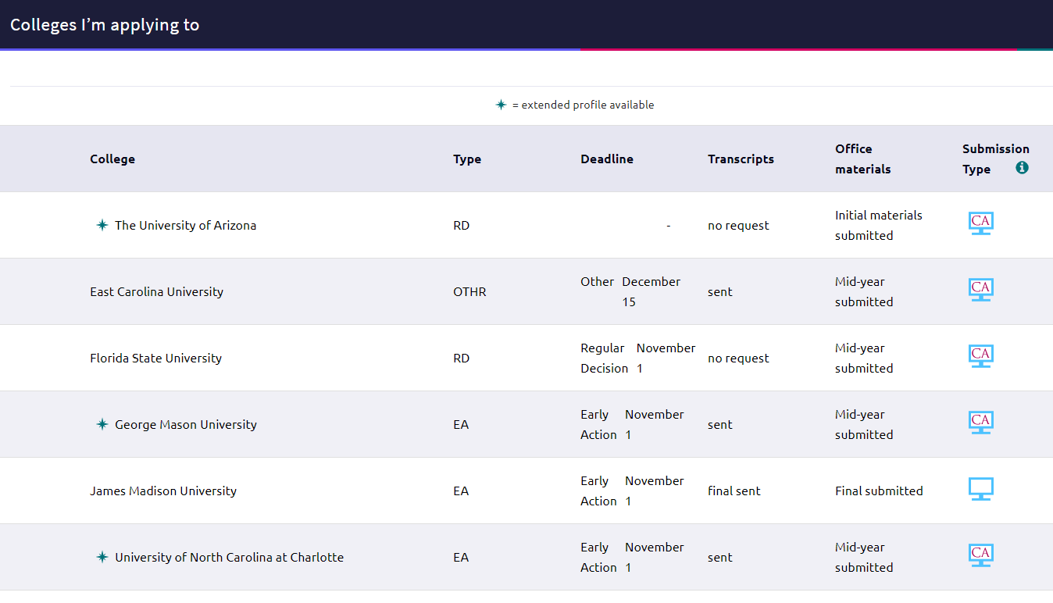

***What is the difference between Early Action and Early Decision Deadlines?***

***Early Action***—you submit your application before regular deadlines on a date set by the college(s) and receive your decisions earlier than usual. You may apply to several schools under Early Action. Your admission is *non-binding* (you do not have to commit until May 1st)

***Early Decision***—you submit application to your *first-choice* college before regular deadline with the understanding that if admitted, **you will attend and withdraw applications from other colleges**. You receive your decision earlier than regular deadline. **You apply to only one school Early Decision and should be willing to commit regardless of financial offering**. See link below for additional information. And talk with admissions office of the college you’re considering applying ED to learn more about their admissions decisions.

[www.bigfuture.collegeboard.org/get-in/applying-101/the-facts-about-applying-early-is-it-right-for-you](http://www.bigfuture.collegeboard.org/get-in/applying-101/the-facts-about-applying-early-is-it-right-for-you)

***Should I apply Early Decision?***

It depends. Talk to the college’s admissions officer to determine if you are a strong candidate for ED.

***Where do I go to find scholarships?***

You should first check the college’s website for possible scholarships you may qualify for. Regularly check **Naviance Scholarship page** and the PTHS Counseling **Financial Aid/Scholarship page** <https://patrioths.pwcs.edu/our_school/school_counseling/scholarships___awards_financial_aid>

<https://student.naviance.com/colleges/scholarships>